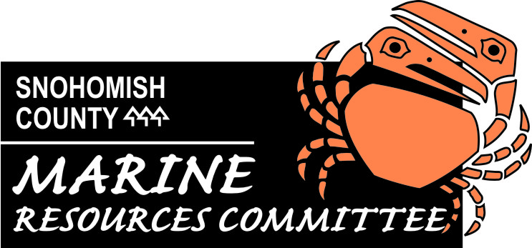

SNOHOMISH COUNTY

MARINE RESOURCES ADVISORY COMMITTEE
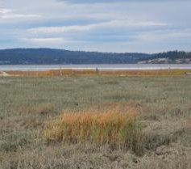
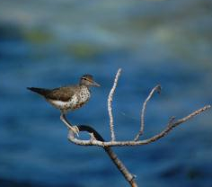
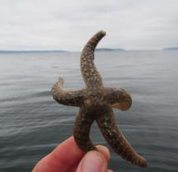

2014 ANNUAL REPORT
& RECOMMENDATIONS


Table of Contents

Background/Introduction…………………………………………………………4

Successes & Highlights………………………………………………………….5

Public Education & Outreach……………………………………………………7

Dungeness Crab.………………………………..………………………………..8

Nearshore Habitat Protection & Restoration…………………………………..9

Port Susan Marine Stewardship Area…………………………………………10

Marine Water Quality……………………………………………………………11

Administrative Tasks…………………………………………………………….12

Opportunities for 2015…………………………………………………………..13

Recommendations to Snohomish County Executive & Council……………14

Acknowledgements……………………………………………………………...16

Attachment A: Trainings………………………………………………………...19

Snohomish County

Marine Resources Advisory Committee (MRC)

Background / Introduction

This report outlines the Snohomish County Marine Resources Advisory Committee’s (MRC) accomplishments between January 1, 2014 and December 31, 2014. It includes a description of current projects and provides recommendations for the Snohomish County Executive and Council.

The MRC was established in 1999 to advise Snohomish County on approaches to conserve the local marine environment. Authorized by Chapter 2.800 of the Snohomish County Code, the MRC advises the County Council and Executive on marine resource issues.

MRC members represent a diverse group of environmental, recreational, conservation, economic, local and tribal government interests. The MRC is part of the Northwest Straits Marine Conservation Initiative (NWSI), guided by the Northwest Straits Commission (NWSC) and the Northwest Straits Foundation (NWSF). Together these entities comprise a non-partisan regional effort to protect and restore marine resources in northern Puget Sound and the Strait of Juan de Fuca. Snohomish County Public Works Surface Water Management Division (SWM) provides staff support for the MRC.

Since its inception, the MRC has developed an effective citizen-based process for examining local marine resource issues, engaging and educating the public and initiating efforts to address established priorities. These priorities are guided by the MRC Strategic Plan (2011-2016) and the NWSC Benchmarks, which include marine habitat, marine life, marine water quality, science, and education and outreach.

The MRC continues to develop a variety of partnerships with government agencies, non-profit organizations and citizen groups to share resources and improve its long-term success. An integral part of the MRC’s work is public education and involvement, which includes the training and use of volunteers. Without the help of volunteers, the MRC would not be able to successfully complete many of its important projects.

The MRC’s efforts have provided a solid foundation of tools and knowledge to fulfill its mission. With a strong emphasis on accountability, the MRC strives to maximize results, build stakeholder confidence and leverage external funds and partnerships.

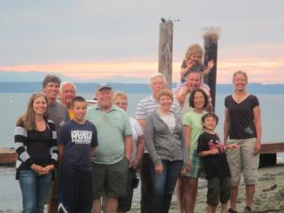
The MRC is now implementing a number of marine conservation research, outreach, and on-the-ground restoration projects, which leverage funds and expand partnerships throughout the county. The MRC members are proud of their accomplishments over the past year and look forward to facilitating continued support and improvements for the marine resources in Puget Sound.
Snohomish MRC Members, Staff and families at summer potluck in Port Susan

Successes and Highlights of 2014

Volunteer Hours

A combined total of 7,940 volunteer and in-kind support hours were leveraged through the work of the Snohomish County Marine Resources Committee (1,624 hrs), and the WSU Snohomish County Extension Beach Watchers (6,316 hrs). These volunteer hours indicate a high level of community support.

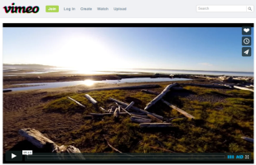
Meadowdale Feasibility Study
The MRC is working with Snohomish County SWM and the Parks Department, along with consultant Anchor QEA to develop alternatives to a culvert at Lunds Gulch creek which enters Possession Sound at Meadowdale Beach. Currently, beach access is limited over the winter months due to high creek water and sediment flows downstream. Additionally, non-natal juvenile chinooks use this stream and fish passage is limited by a walking grate for people to access the beach. The goal of the project is to improve fish habitat and public access to Puget Sound.

In 2014, Anchor QEA was hired as the consultant. Stakeholder and community meetings were held in December of 2014 to discuss evaluation criteria for the alternatives. The community meeting had over 50 local residents in attendance showing strong support for the County to continue to work to address this problem.

Anything else to add here?

Port Susan video posted on Vimeo
New Videos Released
The MRC contracted with Faith Haney, Transect Films, to create two videos focused on MRC projects.

The first, “Ghost Pots of Puget Sound,” features the MRC’s work to remove derelict crab pots from Port Gardner each year. Filming took place during the December 2013 removal of 92 crab pots.

The second video, “Port Susan Marine Stewardship Area,” features interviews with stakeholders in the region including Stillaguamish tribe staff, MRC staff, and local farmers. The video premiered at the Focus on Farming Conference attended by over 500 people and was also shown at the annual MRC Conference in Port Townsend. The video has received over 600 views on Vimeo since it was released.

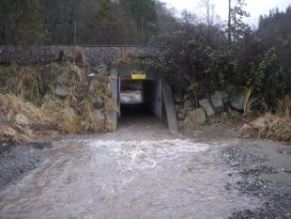

Lunds Gulch Creek culvert at Meadowdale Beach during a flooding event

Successes and Highlights of 2014

Port Susan Resolution
In May 2014, the Snohomish County Council designated Port Susan as a Voluntary Marine Stewardship Area. The Island County Council, Tulalip Tribes, and Stillaguamish Tribe passed similar measures in the past few years. A marine stewardship area gives local authorities and marine users a framework for conservation of the natural, economic and scenic environments.

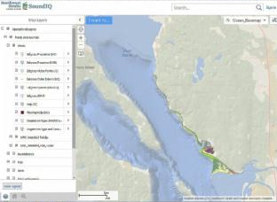
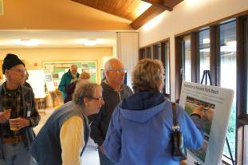
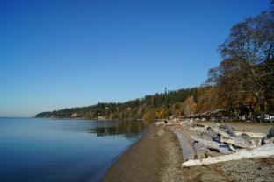
Sound IQ map displaying Snohomish County intertidal data

Nearshore Public Meeting

Snohomish County held a public information meeting on April 24, 2014 to brief interested local residents on details of the project that includes sediment nourishment at up to three locations and beach restoration at Howarth Park. Kathleen Herrmann presented the overview to approximately 43 people in attendance. The project team answered questions following the presentation. Overall attendees were interested and highly supportive of the project, and even offered to volunteer if needed.

Sunset Clause Removed

Snohomish County MRC members and staff met with Snohomish County Councilmembers to discuss the removal of the sunset clause from County Code. The MRC was set to sunset on September 2, 2014. After meeting with the Councilmembers, a resolution was passed eliminating the sunset clause from County Code.

Nearshore Public Meeting attendees viewing a map of the project area
Sound IQ

Snohomish County MRC worked with SWM and NWSC staff to make MRC GIS data available on Sound IQ. Sound IQ is an online database that currently displays nearshore data from Island, San Juan, and Jefferson MRCs. Snohomish data will be available for public viewing by early 2015.

View of Port Susan from Kayak Point County Park

Public Education and Outreach

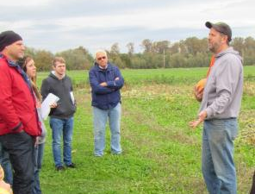
2014 Accomplishments
Port Susan Tour – In October 2014, Snohomish MRC staff hosted a tour of Port Susan for University of Washington graduate students in the School of Marine and Environmental Affairs. Highlights included a tour of the Klesick Family Farm and a walk through the restored Port Susan Bay Preserve completed by The Nature Conservancy.

Ocean Health Forum – On May 14, 2014, the MRC co-hosted a Community Forum on Ocean Health with the Northwest Straits Commission. Presenters included Dr. Terrie Klinger, Simon Geerlofs, and Betsy Peabody. Despite being a sunny summer day, the event was attended by over 45 people.

Starlight Beach Walk – MRC Members, staff, and WSU Snohomish County Extension Beach Watchers hosted two Starlight Beach Walks in 2014: one in Edmonds on January 27 and the other in Mukilteo on February 26. During the evening low tide, people of all ages combed the beach to find starfish, anemones, limpets, crabs, squid, sea slugs and other intertidal organisms.

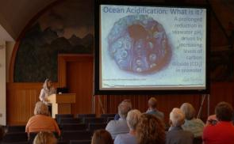
Dungeness Crab
Dr. Terrie Klinger presenting at the Community Forum on Ocean Health
2014 Workplan Highlights

Education and Outreach Events
The MRC booth was displayed at the following events:
- Sound Waters
- ORCA Marine Debris Event
- Snohomish County Beach Watchers Open House
- Nearshore Public Information Meeting
- Community Forum on Ocean Health
- Puget Sound Speed Crabbing Derby
- Sound Living
- NOAA Nite
- NWSC Conference

NWSC Benchmarks Achieved:
Education and Outreach
Washington State University Snohomish County Extension Beach Watchers
The MRC continued partnership and support for the WSU Snohomish County Extension Beach Watchers program

Fifteen Beach Watchers graduated from the 2014 training program and became involved in MRC projects and other local efforts. WSU Beach Watcher volunteers contributed 6,316 hours of service for the community.
Tristan Klesick talking to UW grad students about sustainable farming in Port Susan
2014 Accomplishments
Puget Sound Speed Crabbing Derby
MRC members and staff attended the daylong event held on the Everett waterfront. Event organizers and MRC members distributed packets of education materials including copies of the “Keep Your Crab Pot, Eat More Crab” nautical chart which features best management practices to reduce the number of lost crab pots. The MRC also provided assistance at the weigh station, measuring crabs and testing shell hardness, and educating participants on local regulations and best practices.
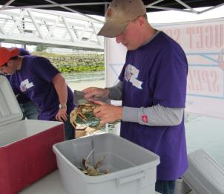
2014 Workplan Highlights
Dungeness Crabber Education
The MRC began developing a social marketing campaign with the goal of reducing crab pot loss in Snohomish County waters.

In December 2014, the MRC hosted a focus group with experienced recreational crabbers to gather information on best management practices as well as understand the barriers to behavior change. The MRC developed a list of potential projects to influence behavior and promote proper crabbing techniques. This project will continue into 2015 with the implementation of the social marketing strategy.

Crab Pot Escapement Study Advisory Committee
MRC members and staff served on the advisory committee for a study being conducted by the Northwest Straits Foundation. The study will determine which of several commonly used recreational crab pot designs in the Puget Sound are most effective, after becoming disabled, in allowing Dungeness crabs to escape.

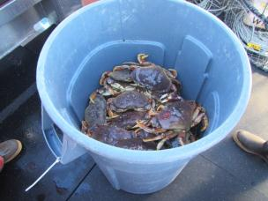
Nearshore Habitat Protection & Restoration
Dungeness crab being collected for the Crab Pot Escapement Study
NWSC Benchmarks Achieved:
Education & Outreach, Marine Life, Marine Habitat

Did you know?
An estimated 12,000 crab pots are lost in the Puget Sound each year!
MRC member, Brent Hackney, measures Dungeness crabs at the Speed Crabbing Derby

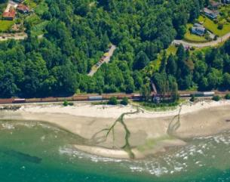
2014 Accomplishments
Nearshore Beach Restoration Project –
This project will advance restoration in the nearshore area of the Snohomish River mouth, along the railroad-impounded shoreline between Mukilteo and Everett by removing armoring at Howarth Park and placing additional beach material at three locations. In 2014, the final designs were approved by the project team. A three way Interlocal agreement between Snohomish County, City of Everett, and the Port of Everett was signed.

In early 2014, AMEC Environmental and Infrastructure, Inc. conducted a cultural resources assessment at Howarth Park, site of the Snohomish County Nearshore Beach Restoration project. No historic properties were found at this time.

The project team obtained grant funding for construction which is planned for late summer/fall 2015. Grants have been awarded by the Salmon Recovery Funding Board, US Fish and Wildlife Service and the US EPA.

Project partners include the Port of Everett, Snohomish County Surface Water Management, the USACE, the City of Everett and the Tulalip Tribes.

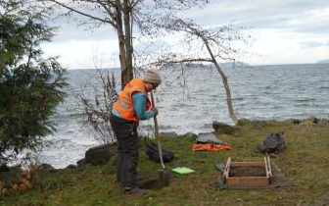
Port Susan Marine Stewardship Area
AMEC Cultural Resources Assessment at Howarth Park
NWSC Benchmarks Achieved:
Science, Marine Habitat
Forage Fish Spawning Surveys
The MRC continued to conduct pre-restoration monitoring of potential forage fish spawning within the Nearshore Restoration Project reach. MRC members, SWM staff and Snohomish County Beach Watchers collected samples between October 2013 and February 2014 to look for the presence or absence of surf smelt and sand lance eggs. The results of the surveys will provide baseline data for the Nearshore Restoration Project.

Forage Fish Spawning Survey Training
MRC members and staff attended a forage fish survey training on June 16, 2014 hosted by Washington Department of Fish and Wildlife biologists. WSU Beach Watchers who assist with the project also attended. Participants were trained on how to sample and winnow for forage fish eggs in the nearshore.

Key partners include WSU Snohomish County Extension Beach Watchers and forage fish expert, Dan Penttila.
2014 Workplan Highlights

Artist’s rendering of the restoration project to remove riprap from the beach at Howarth Park in Everett.

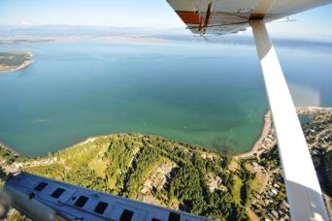

Aerial photo of Port Susan from Cavalero Point
(Credit: Christopher Krembs)

2014 Accomplishments
Incentives Project
The MRC worked with Futurewise to develop recommendations for shoreline incentives programs that will improve nearshore habitat.

A Port Susan Incentives Workshop was held on July 2, 2014. Key stakeholders attended and provided insight into the most effective shoreline protection incentives for Snohomish County. As a result of the workshop and stakeholder interviews, four incentives rose to the top of the list for consideration for a pilot project:
- Establishing a Beach Management District
- Creating a Shoreline Education and Technical Assistance Program
- Offering focused shoreline grants or cost-share awards to landowners
- Adding a shoreline component to Snohomish Conservation District’s Program.
Work with stakeholders suggested that multiple incentives could be combined to create a program that includes three key elements: funding, permitting/technical assistance, and education/demonstration.

What is a Marine Stewardship Area?
A Marine Stewardship Area (MSA) is a non-regulatory conservation designation that works to generate responsibility within relevant authorities and users of marine environments for the conservation of natural, cultural, and scenic values.

Port Susan Report Card
The MRC contracted Abby Hook with Hook Knauer, LLC to review the strategies identified in the Port Susan Marine Stewardship Area Conservation Action Plan (CAP) and identify progress made since 2012. Project partners were interviewed to create a report card to document progress made towards each of the six targets: embedded invertebrates, Dungeness crab, beaches and forage fish, deltas, shorebirds, and Chinook salmon. A final graphic version of the report card will be distributed to project partners in early 2015.

Partnering Agencies
- Island County MRC
- Tulalip Tribes
- Stillaguamish Tribe
- The Nature Conservancy
- WSU Extension of Snohomish County
- WSU Extension of Island County
- Washington Sea Grant
- Snohomish County SWM
- Stillaguamish Watershed Council
- Snohomish County Native Plant Program
- Snohomish Conservation District
- Snohomish County PDS
- Futurewise

NWSC Benchmarks Achieved:
Education & Outreach, Science, Marine Habitat, Marine Life, Marine Water Quality
NWSC Benchmarks Achieved:
Education & Outreach, Science, Marine Habitat, Marine Life, Marine Water Quality

Marine Water Quality
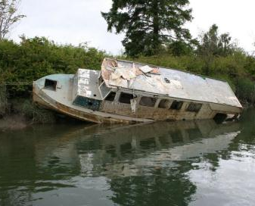

2014 Accomplishments
Derelict Vessel Removal – Snohomish County MRC Staff and members worked with the Washington Department of Natural Resources to support removal of seven derelict vessels in the Snohomish River Estuary in late September 2014. This is a great partnership between the Public Works, the MRC, Snohomish County Sheriff’s Department and DNR and provided almost $400,000 in state funds to Snohomish County to help address a pollution and habitat concern that has affected the estuary for a number of years.

`
One of seven derelict vessels removed from Steamboat Slough
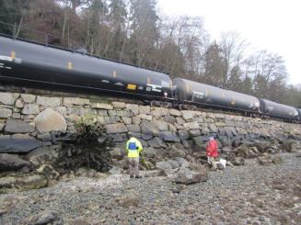
2014 Workplan Highlights

Oil Spill Preparedness
The MRC formed a subcommittee to review the 2011 Oil Spill Preparedness and Response report written by University of Washington students and take action on the recommended steps in the report.

After reviewing the report, the subcommittee met with Snohomish County Department of Emergency Management (DEM) and Washington Department of Ecology on separate occasions to explore gaps in oil spill preparedness in Snohomish County and where the expertise of the MRC would be beneficial. The MRC plans to continue to work with DEM on this project and work to begin filling some of the gaps in County oil spill preparedness in the coming year.

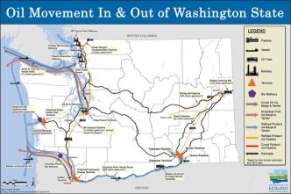
Administrative Tasks
NWSC Benchmarks Achieved:
Science, Education and Outreach, Marine Water Quality
Top: Train travelling along the nearshore south of Everett
Bottom: Graphic showing oil movement throughout Washington State (Credit: DOE)
Map of WDFW Caged Mussel Watch Sites in Puget Sound
NWSC Benchmarks Achieved: Local Participation, Habitat, Scientific Data, and Outreach and Education

Grant Administration
MRC staff submitted progress reports, provided detailed deliverable task reports and included all associated pictures and hardcopies to the Northwest Straits Commission. Staff also developed and tracked the MRC budget.

The current NWSC Grant also provides funding to conduct the Port Susan Phase I Bulkhead Removal Assessment which is currently underway.

MRC Website
The MRC website features a user-friendly interface and individual project pages. It is regularly updated with events, project progress and interesting marine-related information. In 2014, the site received over 4,000 visits.

MRC Staffing
MRC staff received support from the Snohomish County Public Works and the Surface Water Management Division for the Marine Resources Program. Beyond the MRC Program Manager and Lead Staff, Kathleen Herrmann, many SWM employees have contributed time and expertise to MRC projects this year.

MRC Meetings and Communication
MRC staff organized MRC meetings, facilitated meeting and training logistics, and transcribed meeting minutes. Staff maintained phone and email contact with MRC members, MRC subcommittees, County staff, contractors, local community groups, volunteers and the public.

The MRC’s Northwest Straits Commission (NWSC) Representative and/or the Designated Alternate attended NWSC meetings on January 31, February 21, March 20-21, April 25, May 30, June 27, July 25, August 22, September 26, and October 24, 2014. Ten Snohomish County MRC members and two MRC staff attended the NWSC conference in Port Townsend, WA on December 5-6, 2014.

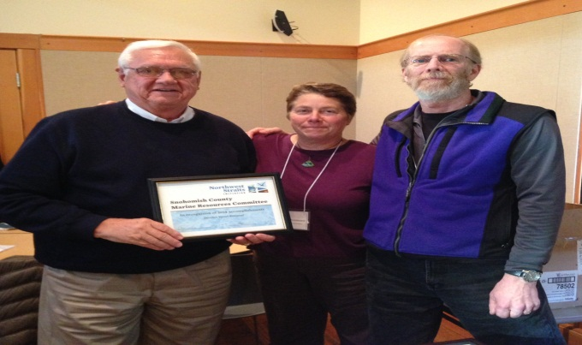

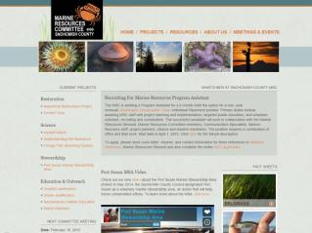
Opportunities for 2015
Tom Hoban accepts award recognizing the MRC for derelict vessel removal project (Credit: Holly Faulstich)
MRC Subcommittees
The MRC maintains an Executive subcommittee and several ad-hoc committees including Mussel Watch, Port Susan, Crabber Education, Derelict Gear, Sound IQ, and Oil Spill Preparedness.

Strategic Plan
The MRC functions under the framework of the 2011-2016 Strategic Plan. The plan guides current and future MRC projects and efforts.
MRC Website: www.snocomrc.org
MRC Members
In January 2014, Paul Schlenger was elected to serve as the MRC Chair. Lincoln Loehr was elected as the MRC representative to the NWSC, with Tom Hoban and Kathleen Herrmann as alternates.

Simon Geerlofs was re-appointed to serve as MRC Co-Vice Chair and Franchesca Perez was appointed as Co-Vice Chair. Simon is a marine science and policy analyst with Pacific Northwest National Laboratory. Franchesca is the Shellfish Program Manager at the Stillaguamish Tribe.

MRC Member Training
See Attachment A for details.
Continuation of Existing Projects:

Derelict Gear Prevention Education
In addition to the 12,000 crab pots lost annually in Puget Sound, derelict nets can also negatively impact marine life and habitat. Over 240 different species have been found in derelict nets. As the MRC has partnered with WSU Beach Watchers to share practices to minimize crab pot loss, the Northwest Straits Initiative (NWSI) has worked to remove derelict fishing nets throughout the Salish Sea. As of September 2014, the NWSI has removed 5,150 derelict fishing nets and 3,695 crab pots from the Puget Sound, restoring 732 acres of critical marine habitat. Over 380,000 animals have been removed from derelict gear since the program began in 2002.
The NWSI estimates a cost of $190 to remove a single derelict crab pot. This high cost emphasizes the value of prevention. Continued outreach efforts are needed to promote best management practices to prevent crab pot loss and reduce derelict gear within Snohomish County waters and throughout the Salish Sea.

Oil Spill Preparedness and Response
In 2011, the MRC sponsored University of Washington Certificate Program students to conduct a review of Snohomish County oil spill preparedness and response and suggest areas for improvement. The MRC convened a subcommittee to revisit the report and research gaps in Snohomish County preparedness to assist in ensuring the county is prepared for a marine spill. The MRC created a focused list of potential projects to assist in accomplishing this goal including observing a tabletop exercise, recruiting volunteers for a vessel of opportunity program, and joining a Northwest Area Contingency Plan (NWACP) task force.

In 2015, the subcommittee will select and pursue implementation of projects that will have the greatest impact on Snohomish County’s oil spill preparedness.

Meadowdale Beach Restoration Feasibility
Meadowdale Beach Park consistently experiences fish barrier, public access and maintenances issues at the Lund’s Gulch Creek culvert. The culvert the runs under the BNSF railroad, provides the only public access to the beach from this location. Gravels transported and deposited by the creek upstream, within and downstream of the culvert have significantly increased over the last few years creating negative impacts at the park.

Snohomish County Parks and Surface Water Management are working with consultant Anchor QEA to evaluate long term solutions. Goals of the project include enhancing recreational and education uses of the park, improving fish habitat, and reducing maintenance on the current culvert. MRC and Snohomish County staff will continue working with Snohomish County Parks to select the best alternative for this site.

New Project Ideas:

- Kelp Monitoring Project
- Coastal Streams Initiative
- Ocean Acidification Outreach

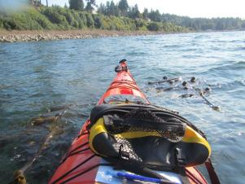
Kelp monitoring via sea kayak

Recommendations to the Snohomish County Executive & Council
The Snohomish County Marine Resources Advisory Committee presents the following recommendations for consideration by the Snohomish County Council and Executive. These include actions that Council and/or the Executive could take, in addition to general support of the current MRC work program. The MRC welcomes further discussion of these recommendations.

Primary Recommendations
- Maintain dedicated, stable funding sources and staff for the Marine Resources Advisory Committee. With more than 7,940 volunteer hours donated to this program by Snohomish County citizens in 2014, the projects supported by the MRC are prime examples of the public/private partnerships that support effective, sustainable stewardship of our marine resources.
- Encourage implementation of the strategies developed in the Port Susan Marine Stewardship Area Conservation Action Plan.
- Support the efforts of the Northwest Straits Marine Conservation Initiative and encourage the continuation of federal funding for this nationally recognized, locally driven program.
- Support, encourage, and fund nearshore habitat restoration capital projects.
- Prioritize marine resource stewardship in departmental work plans, budget development, and local and regional initiatives, such as transportation and economic development.
- Ensure marine shoreline development projects in Snohomish County are coordinated with respect to mitigation of comprehensive and cumulative effects on our shoreline and marine resources.
- Support partner and agency efforts to protect and restore marine shoreline habitat.
- Support the Snohomish and Stillaguamish Watersheds Local Integrating Organization (LIO). The LIO and its committees, to which the MRC belongs, works on behalf of local organizations who aim to protect and restore the Puget Sound.
Additional Recommendations
Public Involvement and Education
1. Continue to encourage citizen involvement in marine resource monitoring and protection opportunities. The leadership of the County Executive and County Council in promoting this type of stewardship is critical to the MRC’s success in educating citizens about the marine environment.
2. Promote and expand partnerships with agencies, tribes, municipalities, universities, community colleges, non-profit organizations and citizen groups.
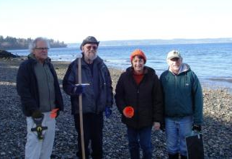

Snohomish County Beach Watchers assist with forage fish spawning surveys at Howarth Park

Additional Recommendations (continued)
Dungeness Crab Stewardship/Derelict Gear Removal
1. Support the efforts of the Northwest Straits Initiative to complete the removal of derelict fishing gear in local waters.
2. Encourage and facilitate partnerships with agencies, tribes, municipalities, universities, community colleges, non-profit organizations and citizen groups to protect and restore Dungeness crab habitat.
3. Recommend and/or support sustainable and appropriate harvest regulations for Dungeness crab.
4. Support statewide development of a “Priority Habitat and Species” designation for Dungeness crab habitat.
Nearshore Habitat Protection and Restoration
- Support the Nearshore Beach Restoration Project for enhancement of the marine nearshore between the Cities of Mukilteo and Everett. Continue partnership with the City of Everett, the Port of Everett, and other landowners to implement project.
- Continue to support the MRC’s role in the Port Susan Marine Stewardship Area (MSA). Continue to work with local stakeholders to establish a community-supported MSA that will result in effective policy implementation with on the ground activities.
- Support partnerships targeted to protect and restore marine shoreline habitat, and encourage private ownership participation in these activities.
- Support, encourage, and fund nearshore habitat restoration capital projects, especially softshore protection demonstration projects.
- Acknowledge and begin to address the impact of climate change and anticipated sea level rise on marine resources.
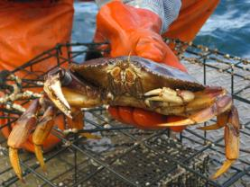
- Support and fund the efforts of the Parks Department and the MRC to restore the nearshore habitat at Meadowdale Park.
Dungeness crab
- Support and fund the full restoration of the Snohomish County Smith Island Tidal Marsh Restoration Project.
Marine Water Quality
1. Support the recommendations of the UW Environmental Management/MRC evaluation of Oil Spill Risk and Preparedness in Snohomish County. Continue to encourage participation in this effort.
2. Monitor and support legislation that promotes a study of the risks associated with the increased transport of oil by rail along the Snohomish County shoreline.
Regional Puget Sound Conservation Efforts
- Continue to participate in the Puget Sound Partnership’s Ecosystem Coordination Board and serve in a leadership role in the Whidbey Island Action Area to improve the health of Puget Sound and enhance the quality of life for Snohomish County citizens.

Acknowledgements

The accomplishments and current activities of the Snohomish County MRC depend on contributions from volunteers, Snohomish County staff members, and individuals from other organizations. Many of our MRC partners are listed below. Their interest and participation in MRC activities is greatly appreciated. We apologize for any omissions.

Snohomish County MRC Members

Paul Schlenger, Chair, Confluence Environmental Company, Fish Biologist and Marine Ecologist, Environmental Interest
Simon Geerlofs, Co-Vice Chair, Pacific Northwest National Laboratory, Marine Science and Policy Analyst, Conservation/Environmental Interest
Franchesca Perez, Co-Vice Chair, Stillaguamish Tribe, Marine Stewardship and Shellfish Program Manager, Local Tribal Government
Thomas Hoban, Coast Commercial Properties, Real Estate Broker,
Economic Interest
Keeley O’Connell, EarthCorps, Senior Restoration Ecologist, Conservation/Environmental Interest
Brent Hackney, Brent Hackney Designs, Inc., Owner, Economic Interest
Lincoln Loehr, Environmental Consultant, Conservation/ Environmental Interest
Cathy Stanley, Tulalip Tribes, Shellfish Biologist, Local Tribal Government
Susan Tarpley, City of Edmonds Discovery Programs, Ranger-Naturalist, Environmental Interest
Bob Hillmann, City of Everett, Parks Department, Project Coordinator, Local Government
Mike Ehlebracht, Hart Crowser, Geochemist, Economic Interest
Mike Montanari, Coastal Tourism Research, Economic Interest

Snohomish County Marine Resources Program Staff

Kathleen Herrmann, Lead Staff

Alyson Rae, Program Assistant

Port Susan Marine Stewardship Area

Abby Hook, formerly with Tulalip Tribes, Hook-Knauer LLC
Brett de Vries, Snohomish Conservation District
Kathleen Herrmann, Snohomish MRC Staff
Caroline Gibson, NWSC
Chrys Bertolotto, WSU Snohomish County Extension
Franchesca Perez, Stillaguamish Tribe
Gina Gray, Stillaguamish Tribe
Karen Stewart, Island County
Kat Morgan, Nature Conservancy
Kate Litle, Washington Sea Grant
Monte Marti, Snohomish Conservation District
Sasha Horst, NWSC
Scott Chase, Island County Shore Stewards
Simon Geerlofs, Snohomish MRC
Thomas Hoban, Snohomish MRC
Tracie Johannessen, formerly with NWSF

Dungeness Crab

Brent Hackney, Snohomish MRC
Cathy Stanley, Tulalip Tribes
Franchesca Perez, Stillaguamish Tribe
Don Rothaus, Washington Department of Fish and Wildlife
Don Velasquez, Washington Department of Fish and Wildlife
Tom Hoban, Snohomish MRC
Bob Hillmann, City of Everett
Joan Drinkwin, NWSF
Natural Resources Consultants
Suzi Wong Swint, Snohomish County
WSU Snohomish County Extension Beach Watchers

Public Involvement and Education

Francesca Perez, Stillaguamish Tribe
Tristan Klesick, Klesick Family Farms
Kat Morgan, The Nature Conservancy
Kit Crump, Snohomish County SWM
Dr. Terrie Klinger, University of Washington
Betsy Peabody, Puget Sound Restoration Fund
Faith Haney, Transect Films
Casey Rice, NOAA
Ginny Broadhurst, NWSC
Caroline Gibson, NWSC
Tom Hoban, Snohomish MRC
Lincoln Loehr, Snohomish MRC
Paul Schlenger, Snohomish MRC
Simon Geerlofs, Snohomish MRC
Susan Tarpley, Snohomish MRC
Bob Hillmann, Snohomish MRC, City of Everett
Sally Lider, City of Edmonds
Suzi Wong-Swint, Snohomish County
Stef Frenzl, Snohomish County
Chrys Bertolotto and the WSU Snohomish County Extension Beach Watchers

Nearshore Habitat Protection and Restoration

Coastal Geologic Services
Curtis Tanner, U.S. Fish and Wildlife Service
Dan Penttila, Salish Sea Biological
Dave Lucas, Snohomish County SWM
Debbie Terwilleger, Snohomish County SWM
Alyson Rae, Snohomish MRC Staff
Frank Leonetti, Snohomish County SWM
Scott Moore, Snohomish County SWM
Hugh Shipman, Washington Department of Ecology
Kathleen Herrmann, Snohomish MRC Staff
Kathy Ketteridge, Anchor QEA
Kollin Higgins, King County
Lincoln Loehr, Snohomish MRC
Lisa Kaufman, NWSF
Mark Harrison, Port of Everett
Mary Cunningham, City of Everett
Mike Rustay, Snohomish County
Morgan Ruff, Tulalip Tribes
Paul Schlenger, Confluence Environmental Company
Bob Hillmann, City of Everett
Sean Callahan, NOAA
Todd Zackey, Tulalip Tribes
WSU Snohomish County Extension Beach Watchers

Marine Water Quality

Franchesca Perez, Stillaguamish Tribe, Snohomish MRC
Mike Ehlebracht, Snohomish MRC
Kathleen Herrmann, Snohomish MRC Staff
Susan Tarpley, Snohomish MRC
Rodney Rochon, Snohomish County Sheriff’s Department
Snohomish County Department of Emergency Management
Washington Department of Ecology
Brenda Treadwell, Washington Department of Natural Resources
Alyson Rae, Snohomish MRC Staff

Forage Fish Spawning Surveys
Frank Leonetti, Snohomish County SWM
Mike Rustay, Snohomish County SWM
Kathleen Herrmann, Snohomish MRC Staff
Franchesca Perez, Stillaguamish Tribe, Snohomish MRC
Craig Wollam, WSU Beach Watcher
Alyson Rae, Snohomish MRC Staff
Dan Penttila, Salish Sea Biological
WSU Snohomish County Extension Beach Watchers

Snohomish County Staff Members & Elected Officials

Public Works Department, Surface Water Management Division

Debbie Terwilleger, Director
Ann Bylin, Planning Supervisor
Gregg Farris, SWM-SPA Supervisor
Kathleen Herrmann, MRC Lead Staff
Alyson Rae, WCC IP
Sean Edwards, Senior Planner
Allison Sanders, GIS Analyst
Scott Moore, Native Plant Steward
Suzi Wong Swint, Senior Planner
Frank Leonetti, Senior Habitat Specialist
Mike Rustay, Senior Habitat Specialist
David Lucas, Engineer
Stef Frenzl, Communications Specialist

Department of Parks and Recreation

Tom Teigen, Parks Director
Sharon Swan, Senior Planner
Chris Mueller, Senior Planner
Logan Daniels, Engineer

Snohomish County Executive

John Lovick

Snohomish County Council 2014

Ken Klein - District 1
Brian Sullivan - District 2
Stephanie Wright - District 3
Terry Ryan - District 4
Dave Somers, Chair - District 5

WSU Snohomish County Extension Beach Watchers

Alex Ho
Annette Rosebrook
Barbara Keithly
Bea Wilson
Bernie Busch
Beverly Black
Bill James
Bill McLaughlin
Bob McCort
Bobbie Constantine
Brian Cleveland
Bruce Bennett
Carol Forsberg
Carol Winter
Charlie Stewart
Chris Betchley
Christine Longdon
Chuck LoPresti
Craig Wollam
Darla Gay Smith
Dave Compton
Deanna Stiles
Diane Patterson
Donna Bennett
Donna Kinsey
Donna Maupin
Fred Benedetti
Gary Harshman
Georgeann Silverman
Harlen Forsberg
Heidi Smith
Hugh Matheson
Ila Osburn
Janet Loehr
Jerry Anderson
Joan Douglas
Jourdan Keith
Joy Lynch
Judy Atkins
Judy Ness
Karen Siebrass
Kathy Konarzewski
Kathy Traugott
Larry Whatley
Laurel Nyquist
Lee Kimmelman
Leslie Rafael
Lincoln Loehr
Linda Whatley
Lisa Parkinson
Liz Heisler
Lucinda Diann
Lynn Lichtenberg
Lynn McCort
Margarita Molina
Mary Vanderway
Mauricio Calderon
Melanie Wyffels
Melonique Riall
Michael Kyte
Nancy Engen
Pat Smith
Patrick Deagen
Paul Granquist
Sandy Evans
Scott Montgomery
Shelley Byington
Shian Rashid
Stefan Dittmar
Susan Stewart
Thomas Murphy
Tom Hoban
Trish Mayfield
Ursula Gallagher
Veda Rosier
Wendy Oresik

ATTACHMENT A:

SNOHOMISH COUNTY MRC

SUMMARY OF TRAINING EVENTS

MRC members and staff participated in the following training sessions in 2014:

- Sound Waters
February 1, 2014
Attendees: Lincoln Loehr and Alyson Rae

- Salish Sea Shoreline Forum
February 3, 2014
Attendee: Kathleen Herrmann

- Sea Level Rise Class
February 27, 2014
Attendee: Kathleen Herrmann

- Marine Shoreline Design Guidelines Workshop (Federal Way)
March 20, 2014
Attendees: Paul Schlenger and Keeley O’Connell

- Marine Shoreline Design Guidelines Workshop (Mt. Vernon)
March 25, 2014
Attendees: Bob Hillmann, Franchesca Perez, Mike Montanari, Kathleen Herrmann, and Alyson Rae

- WDFW Hazwoper Training
March 29, 2014
Attendees: Bob Hillmann, Mike Montanari, and Alyson Rae

- Social Marketing Framework for Armoring Behaviors
April 24, 2014
Attendees: Tom Hoban, Kathleen Herrmann, and Alyson Rae

- Salish Sea Conference
April 30-May 2, 2014
Attendees: Franchesca Perez, Paul Schlenger, Lincoln Loehr, Keeley O’Connell, Simon Geerlofs, Kathleen Herrmann, and Alyson Rae

- Salish Sea Shoreline Forum
May 20, 2014
Attendees: Kathleen Herrmann

- WDFW Forage Fish Spawning Survey Training
June 16, 2014
Attendees: Lincoln Loehr, Mike Ehlebracht, Mike Montanari, Paul Schlenger, Bob Hillmann, Kathleen Herrmann, and Alyson Rae

- Social Marketing Training
July 15 and 29, 2014
Attendee: Alyson Rae

- Shoreline Monitoring Toolbox Webinar
July 31, 2014
Attendees: Kathleen Herrmann and Alyson Rae

- Marine Managers Workshop
September 10, 2014
Attendees: Kathleen Herrmann and Paul Schlenger

- Sound Living: One Day Communiversity
October 25, 2014
Attendees: Bob Hillmann, Mike Ehlebracht, Franchesca Perez and Alyson Rae

- Focus on Farming Conference
November 20, 2014
Attendees: Kathleen Herrmann and Alyson Rae

- NWSC Annual MRC Conference
December 5-6, 2014
Attendees: Cathy Stanley, Franchesca Perez, Kathleen Herrmann, Keeley O’Connell, Lincoln Loehr, Alyson Rae, Paul Schlenger, Bob Hillmann, Simon Geerlofs, Susan Tarpley, Mike Ehlebracht and Thomas Hoban

